Paddy Field Drone Simulation
Environment Development Development Report
Prepared for COIT20265: Networks and Information Security Project

Table of Contents
Chapter 1: Introduction 3
1.2 Problem Definition 4
Chapter 2: Literature Review 5
2.1 Autonomous Agriculture Drone 5
2.2 Drone Simulation Platforms 6
Chapter 3: Methodology/System Design 6
3.5 Workflow Diagram 6
Chapter 4: System Implementation 8
4.1 Installing and Configuring AirSim 8
Chapter 5: Testing and Result 8
Chapter 6: Discussion 9
References 10

Chapter 1: Introduction
This report records the environment development and integration component of a drone simulation prototype of a paddy-field. The project is an example of a smart agriculture scenario whereby the weed fields are detected, reflected as useful coordinate information and subsequently, to serve a simulated mission of a drone spraying. The technical bridge in this work is that of transforming agricultural data to be executed in the style of a virtual mission: generating the Unreal Engine/AirSim field environment, preparing coordinate-style data representing the weeds, and interpolating this result to a mission workflow, which can then be simulated.
A simulation-first approach is employed by the prototype due to the high cost, weather-related nature, and riskiness of actual drone tests. AirSim was chosen since it is an open-source drone simulator developed as an Unreal Engine plug-in and also enables experimenting with SITL/HITL (Microsoft, 2024). This was created using Unreal Engine that offers real-time 3D creation, lighting, materials, meshes, and landscape tools of simulation scenes (Epic Games, 2025).
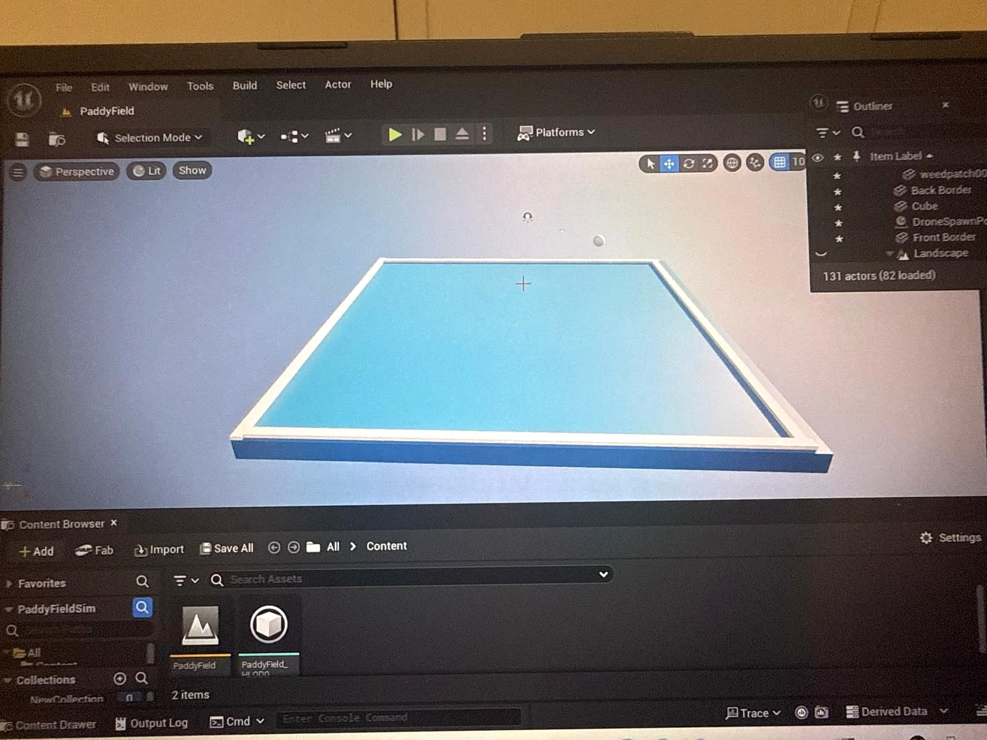
Figure 1: Initial Unreal Engine base platform for the paddy-field simulation environment.

1.2 Problem Definition
Manual control of weeds is common or they are sprayed widely. Inspection by hand is time consuming and blanket spray may waste chemicals and may interfere with healthy crops. The technical requirement of the report is to have a controlled prototype with the capability of demonstrating the locations of the weeds, field arrangement, and the drone mission behaviour. Without an environment and integration workflow decision and navigation logic would not be an operating prototype but instead a script. The particular difficulty was in its success to build an environment resembling a paddy-field with visible crop-plots, weedy areas, water-courses, boundaries, and drone positions as well as to prepare data in a format that could be used to both produce waypoint plans and record spray-actions. The solution had to be easy enough to fit a student capstone prototype, yet understandable enough to demonstrate how this was intended to run through a pipeline of data on where the weeds were and a time-simulated drone spraying.

Chapter 2: Literature Review
UAVs are becoming a common tool in precision agriculture to analyze crops, identify weeds, and assist in making interventions. High resolution low altitude images can be obtained with UAVs, allowing useful field level monitoring. The recent reviews provide such concepts as aerial imaging, artificial intelligence, or target spraying as the key techniques to minimize unproductive usage of chemicals (Zhang et al., 2024; Ehrampoosh et al., 2025). Autonomous drone systems also require repeat testing; hence, simulation can also be useful.

2.1 Autonomous Agriculture Drone
A self-driving agricultural drone consists of a flight platform, sensors, navigation logic and decision-making software. Image processing, KML files, or pre-processed coordinate datasets (as used in a weed-management context) can provide the drone with weed locations. It then transforms those places into waypoints and carries out tasks like monitoring, mapping or spraying. Targeted spraying will be of particular interest since the density of the weeds may not be constant within a field. The isolated weed patches can be treated with a spot-spray decision, whereas the diffuse areas with a high amount of weed can be treated with a blanket-spray decision. In this prototype, autonomy is shown in the form of the organized execution of missions. The drone flies in a set of simulated positions of targets and logs behaveable options like SPOT SPRAY or BLANKET SPRAY, and exercises the logic without actual in-flight danger.

2.2 Drone Simulation Platforms
Simulation drone platforms enable developers to trial navigation, sensing, and mission behaviour, prior to actual implementation. The AirSim is exceptionally applicable as it simulates drones in the Unreal Engine setting and offers APIs to access images, vehicle position, and vehicle control (Microsoft, 2024). The initial AirSim research paper presents the simulator as a high-fidelity visual and physical simulation platform of autonomous vehicle research, which aims at lowering the cost and complexity of evaluating algorithms in the real world (Shah et al., 2017). It is also documented that AirSim can be a type of simulator to enable both physically and visually realistic SITL/HITL workflows to run flight-controller testing (PX4, 2025). In this project, a design requirement is the use of simulation. It enables reproducible situations, screen-shots, logs, and preliminary integration testing prior to any real flight.

Chapter 3: Methodology/System Design
The modular design was adopted in its methodology. Each larger sub-unit of the system was considered as a subunit that received and produced inputs and outputs. The visual field and weed areas are availed by the environment component. The data-processing aspect prepares locations of weed-zone. Decision component categories the spraying action. The integration element translates the outcome into mission-ready mission points and the simulation element illustrates the movement of the drones and spray logging. This is a modular design that makes it less complex since the individual parts may be tested individually before being integrated entirely.

3.5 Workflow Diagram
The data flow starts with input data of agriculture to output of simulation. The weed-zone dataset or a KML file is converted into coordinates. The decision logic is provided with the coordinates. A waypoint mission file is generated out of the decision output. In simulation, mission commands are sent to the drone and ultimately a log of movement or spray-action is generated. The workflow diagram included below summarises the relationship between the environment module and integration module.
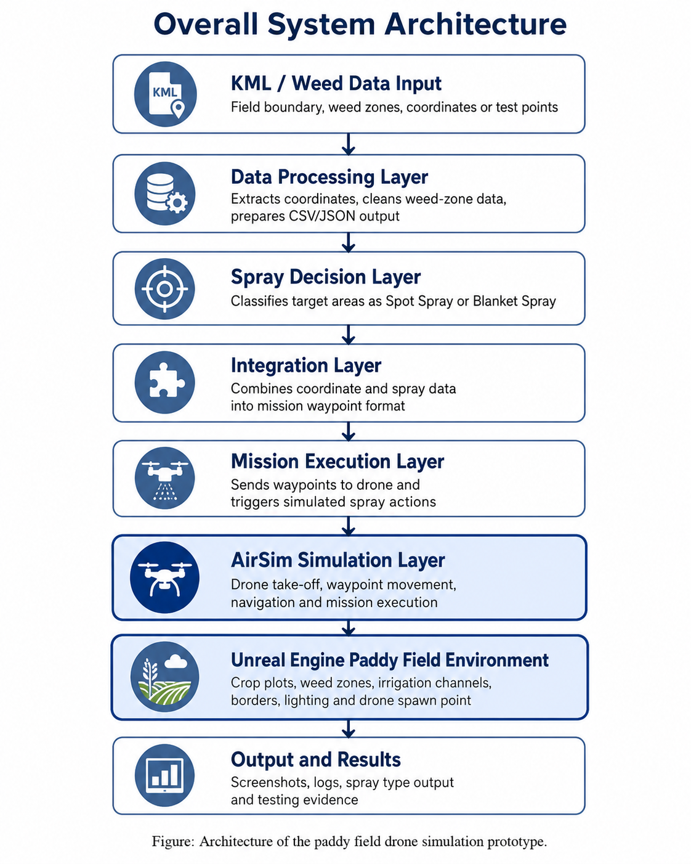
Figure 2: sArchitecture Diagram

Chapter 4: System Implementation
Implementations were done with the creation of the virtual paddy field and the data pathway needed to prepare it to be integrated. The last environment includes a green paddy field, blue irrigation lines, a rectangular field area, yellow weed fields, visible boundaries, surrounding landscape, lights, and a drone/spawn, which is used to test missions.

4.1 Installing and Configuring AirSim
The AirSim setup was the preparation of the simulation connection between the drone system and the environment of the Unreal Engine. The Unreal scene should be capable of drone operation by being able to use AirSim as a drone simulation component or as a drone control and proxy. The project presupposes that appropriate settings file and drone configuration of AirSim are provided prior to execution of the mission. The pertinent settings are vehicle type, simulation mode, starting position and API connection. According to AirSim documentation, its APIs enable programmatic access to vehicles including getting vehicle state and controlling of vehicle behaviour (Microsoft, 2024). This setup has to be checked prior to integration since an environment can open even when it does not seem that the drone has reactive actions to API commands. Simple tests are expected to verify the visibility of drones, API connection, and command response.

Chapter 5: Testing and Result
The testing was performed on the extent to which the environment and integration process was usable, understandable and stable enough to demonstrate the prototype. It was discussed as an evaluation project, rather than a commercial farming system in the form of a prototype.

Chapter 6: Discussion
The finished paper demonstrates that a prototype related to drone-based agriculture involves environment development and integration as its priorities. A decision algorithm is not sufficient, but it has to be attached to a field, a coordinate system, and a mission execution process. Likewise, a visual environment is never sufficient by itself unless it is used to facilitate good data flow and testing. The given project integrates both of the requirements by providing a paddy-field and connecting it to an integration work-flow.
Clarity is the strongest point in the solution. The field map, colours and workflow make one understand how the drone should operate with ease. Improvement in the future is also achievable in the modular architecture. The latter may be further modified with realistic crop assets, simulated water, weather, better terrain, real KML conversion, coordinate calibration (GPS-to-Unreal), automated drone routes and weed detection using the cameras on the cameras. The consideration of ethics and professionalism also holds. An actual drone system needs to obtain and process farm information with direct consent, guard location and image information, and shun gathering individuals or personal property.

References
Ehrampoosh, A. et al. (2025) 'Intelligent weed management using aerial image processing platforms: a review', Computers and Electronics in Agriculture. Available at: https://www.sciencedirect.com/science/article/pii/S0261219425000985 (Accessed: 1 June 2026).
Epic Games (2025) Unreal Engine Documentation. Available at: https://dev.epicgames.com/documentation/unreal-engine (Accessed: 1 June 2026).
Microsoft (2024) AirSim Documentation. Available at: https://microsoft.github.io/AirSim/ (Accessed: 1 June 2026).
PX4 (2025) AirSim Simulation. Available at: https://docs.px4.io/main/en/sim_airsim/ (Accessed: 1 June 2026).
Shah, S., Dey, D., Lovett, C. and Kapoor, A. (2017) 'AirSim: High-Fidelity Visual and Physical Simulation for Autonomous Vehicles', arXiv. Available at: https://arxiv.org/abs/1705.05065 (Accessed: 1 June 2026).
Zhang, J. et al. (2024) 'Advancements of UAV and deep learning technologies for weed detection and management in precision agriculture', Agronomy, 14(3), article 494.

